**Looking Ahead on the Calendar **
Sunday, 6/26 | 11:45 a.m. | Reception for Steve & Annette Stadtherr
Monday, 7/4 |  | Independence Day ~ Church Office Closed
Hosptials:
Lynchburg General: Kitty Boswell, Charles Moore
Reception
There will be a farewell reception after church next Sunday, June 26, in honor of Steve and Annette Stadtherr. It will be "covered dish", which means you can bring just about anything, hot or cold, as long as it's "delicious"! Please let Ann Robbins or Judy Robertson know if you plan to bring something and/or if you can help with set-up, serving, or clean-up.
**Beginning July 1st, we welcome our new Associate Pastor, Erin Long, to Chestnut Hill.

In the Grocery Cart This Month
For June ~ Cereal.
Place donations in the grocery cart, located in the Commons.

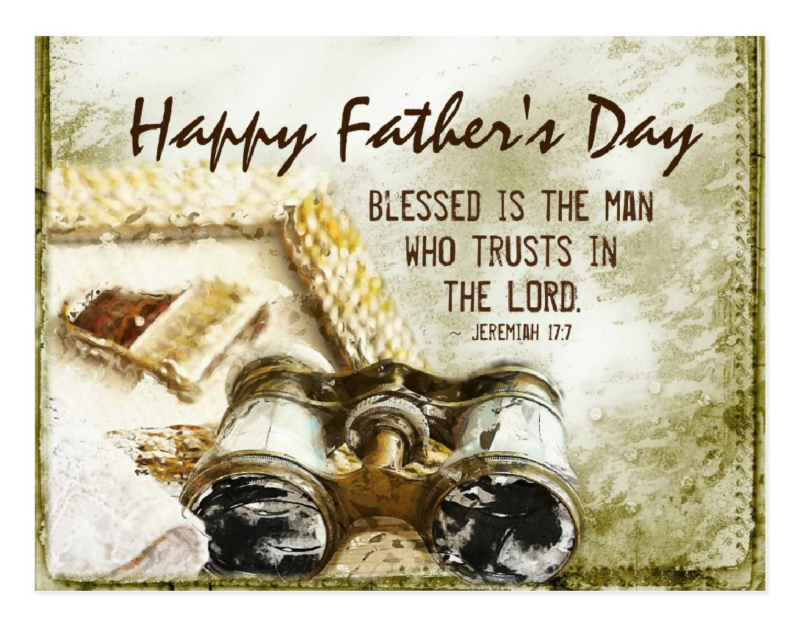



DIRECTORY OF CHESTNUT HILL UNITED METHODIST CHURCH
Sharma Lewis | Richmond Area Resident Bishop
Denise Bates | Lynchburg District Superintendent
Adam White | Minister
Steve Stadtherr | Associate Minister
Monica Campbell | Administrative Assistant
Heather Wilson | Director of Music Ministry
Judy Martin | Bookkeeper
Judy Robertson | Lay Leader

Chestnut Hill
United Methodist Church

Making disciples of Jesus Christ
for the transformation of the world.
You are welcome at Chestnut Hill UMC.

4660 Fort Avenue ~ Lynchburg, Virginia 24502
Church: 434-239-8423
Minister’s Cell: 434-944-7723, Minister’s Email: awhite@ves.org
Associate Minister’s Cell: 434-841-2458
Associate Minister’s Email: sps83.ss@gmail.com
chestnuthillumc@comcast.net ~ on the web at chestnuthillumc.net
Find us on Facebook: Chestnut Hill United Methodist Church

Chestnut Hill United Methodist Church
10:30 a.m. ~ June 19, 2022 ~ Second Sunday after Pentecost
Father’s Day

Our ministry vision for the Virginia Annual Conference is “to be disciples of Jesus Christ who are lifelong learners, who influence others to serve.”
Welcome! Join us in worshiping God!
Prelude “Turn Your Eyes upon Jesus” arr. M. Mier
Welcome and Ministry Announcements
Welcome in the name of Christ our Lord. Please register your attendance,
printing your name, address, phone, and email, on the attendance pad provided on your pew. Thank you for silencing cell phones as we gather to worship God.
Invocation
Greeting
We come to you this day, with burdens and cares in our hearts.
Lord, take these burdens from us and ease our souls.
We come to you this day, with fear and uncertainty about the future.
Lord, calm our fears and help us to place our trust in you.
Come, let us worship God whose love is abundant.
Let us praise the God of our salvation who watches over us always. AMEN.
*Singing Our Faith # 2248 “Baptized in Water” (TFWS)
Opening Prayer
Open our hearts today, O Lord, to feel the powerful strength and love you have for us. Help us to listen, not only with our ears, but with our spirits for your words of compassion and healing. Enable us to become more faithful disciples for you; for we ask this in the name of our Savior Jesus Christ. AMEN.
Greeting Friends and Neighbors

Prayer for Illumination
Guide us, O God, by your Word and Spirit, that in your light we may see light, in your truth find freedom, and in your will discover your peace: through Jesus Christ our Lord. Amen.
Scripture Lesson Luke 8:26-39
The Word of God for the people of God.
Thanks be to God.
Singing Our Faith # 361 “Rock of Ages, Cleft for Me”
The Good News “What consumes you?”
Special Music “I Sing the Mighty Power of God” by I. Watts
Bringing Forward God’s Tithes and Our Gifts
*Doxology # 95 Praise God from whom all blessings flow; praise him, all
Creatures here below; praise him above, ye heavenly host; praise Father, Son, and Holy Ghost. Amen.
*Prayer of Thanksgiving
Sharing of Joys and Concerns
The Lord’s Prayer
Our Father, who art in heaven, hallowed be thy name. Thy kingdom come,
Thy will be done on earth as it is in heaven. Give us this day our daily bread and forgive us our trespasses, as we forgive those who trespass against us. And lead us not into temptation, but deliver us from evil. For thine is the kingdom, and the power, and the glory, forever. Amen.
*Singing Our Faith # 472 “Near to the Heart of God”
*Blessing and Dismissal
*Postlude
Scatter to Serve God & Neighbor
Welcome to all! We gather to praise God for the innumerable blessings given
to us and to grow deeper in the Spirit. Joyfully, let us lift our hearts to God.

